**Question 1**

Code

package ipj_finalassignment;

import java.util.Scanner;

public class question1 {

public static void main(String[] args) {

Scanner sc = new Scanner(System.in);

String dateInput = "";

String[] dateInputArr;

boolean leapYear = false;

int month = -1;

int day = -1;

int year = 01;

System.out.println("Date Validator");

System.out.println("--------------------");

System.out.println("Please input your Date in mm/dd/yyyy format.");

System.out.print("Date: ");

try {

dateInput = sc.next(); // Take user input

dateInputArr = dateInput.split("/", 3); // Split input into month, day, and year parts

month = Integer.parseInt(dateInputArr[0]); // Parse month

day = Integer.parseInt(dateInputArr[1]); // Parse day

year = Integer.parseInt(dateInputArr[2]); // Parse year

} catch(Exception e) {

System.out.println("Reason: Wrong Format. Please follow the format."); // Catch wrong format exception

System.exit(0); // Completely exit the program since the format is already wrong. No need to validate the others.

}

// Check if it is leap year

if (year < 1) {

System.out.println("Reason: Year must not be less than 1."); // Print error message for year less than 1

System.exit(0); // Exit program

}

else if (year % 4 == 0) { // If year is divisible by 4

if (year % 100 == 0) { // If year is also divisible by 100

leapYear = year % 400 == 0; // It is a leap year if also divisible by 400

} else {

leapYear = true; // Otherwise, it is a leap year

}

} else {

leapYear = false; // If not divisible by 4, it is not a leap year

}

// Check if days is correct according to its year and month

if (!(day >= 1 && day <= getDays(month, leapYear))) { // Validate day against month and leap year status

System.out.println("Days has exceeded the corresponding month and/or days is wrong according to year.");

System.exit(0); // Exit program if day is invalid

}

System.out.println("\nYou have Entered " + dateInput + "."); // Print entered date

System.out.println("It is a valid Date."); // Print validation message

}

static int getDays(int x, boolean leapYear) {

int result = 0;

try {

if (leapYear && x == 2) { // If leap year and month is February

result = 29; // February has 29 days in leap years

} else {

int[] daysInMonth = {31,28,31,30,31,30,31,31,30,31,30,31}; // Array representing days in each month

result = daysInMonth[x-1]; // Get days for the specified month

}

} catch (ArrayIndexOutOfBoundsException aioobe) { // Catch invalid month exception

System.out.println("Reason: Month is not within the range of 1 to 12.");

System.exit(0); // Exit program if month is invalid

}

return result; // Return the number of days in the specified month

}

}

|  |  |  |  |
| --- | --- | --- | --- |
| Test Case | Input | Expected Output | Actual Output |
| 1 | "02/29/2024" | "You have Entered 02/29/2024. It is a valid Date." | "You have Entered 02/29/2024. It is a valid Date." |
| 2 | "12/31/2022" | "You have Entered 12/31/2022. It is a valid Date." | "You have Entered 12/31/2022. It is a valid Date." |
| 3 | "13/32/2023" | "Reason: Month is not within the range of 1 to 12. | "Reason: Month is not within the range of 1 to 12. |

Test Case 1 (Successful)

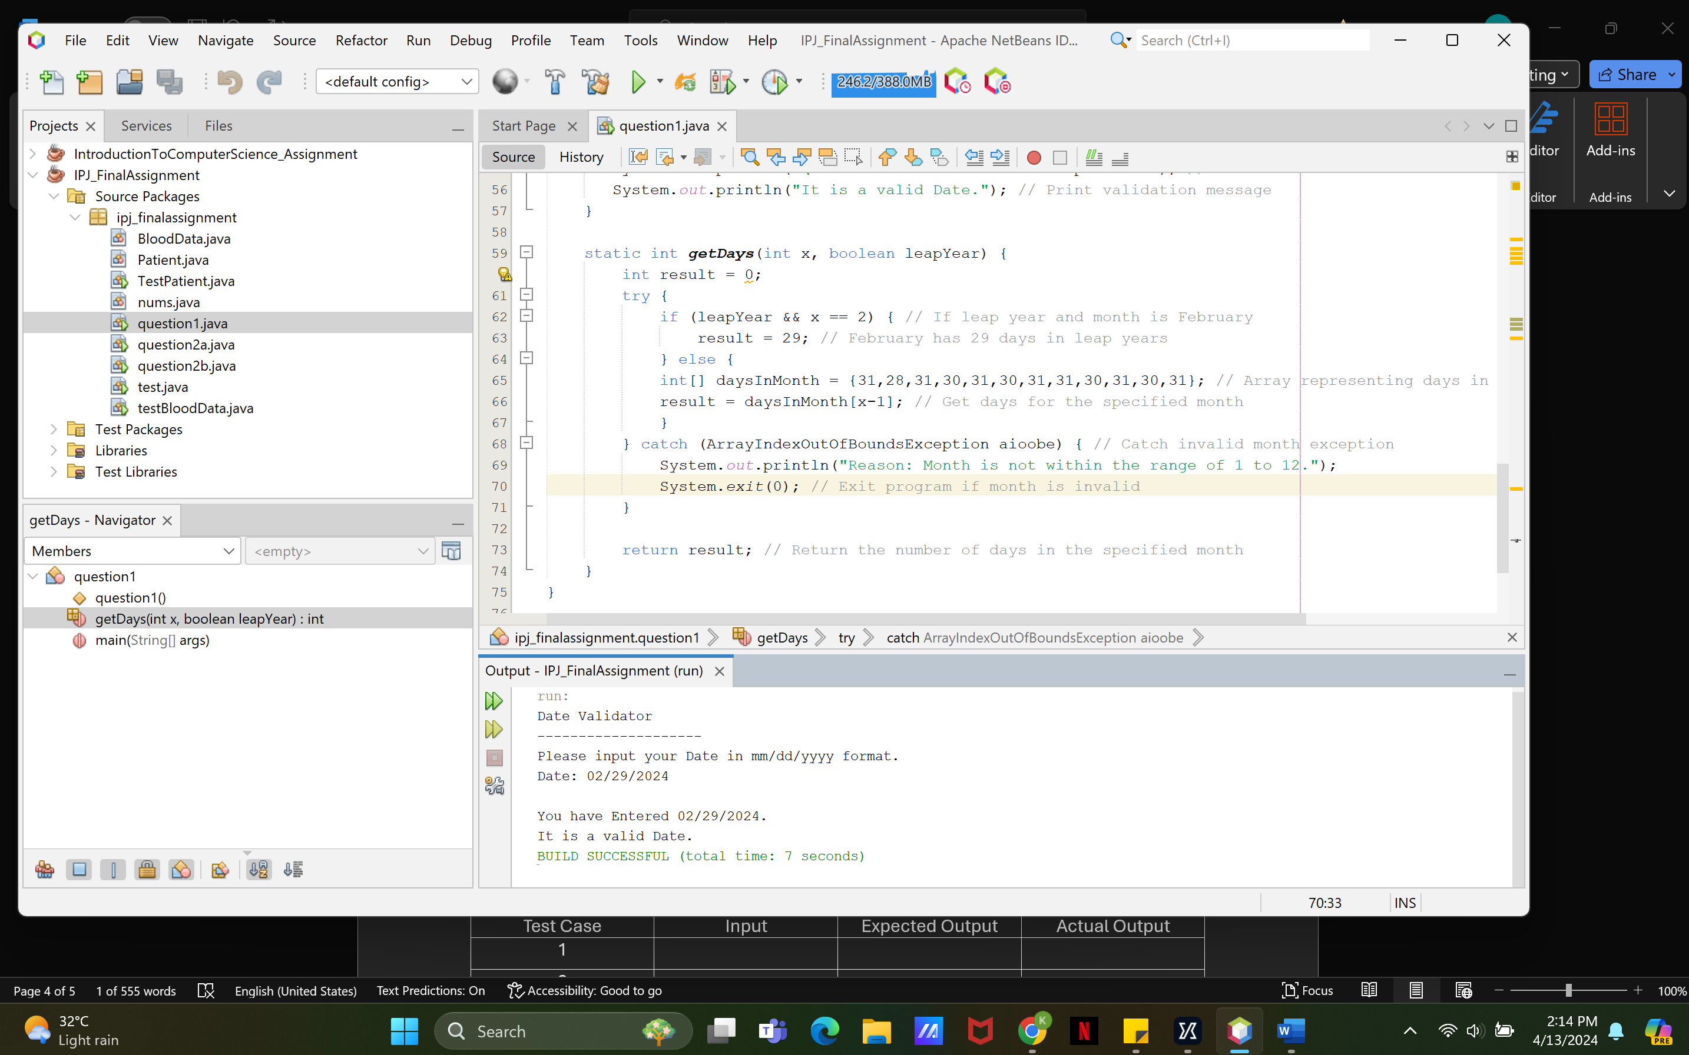

Test Case 2 (Successful)

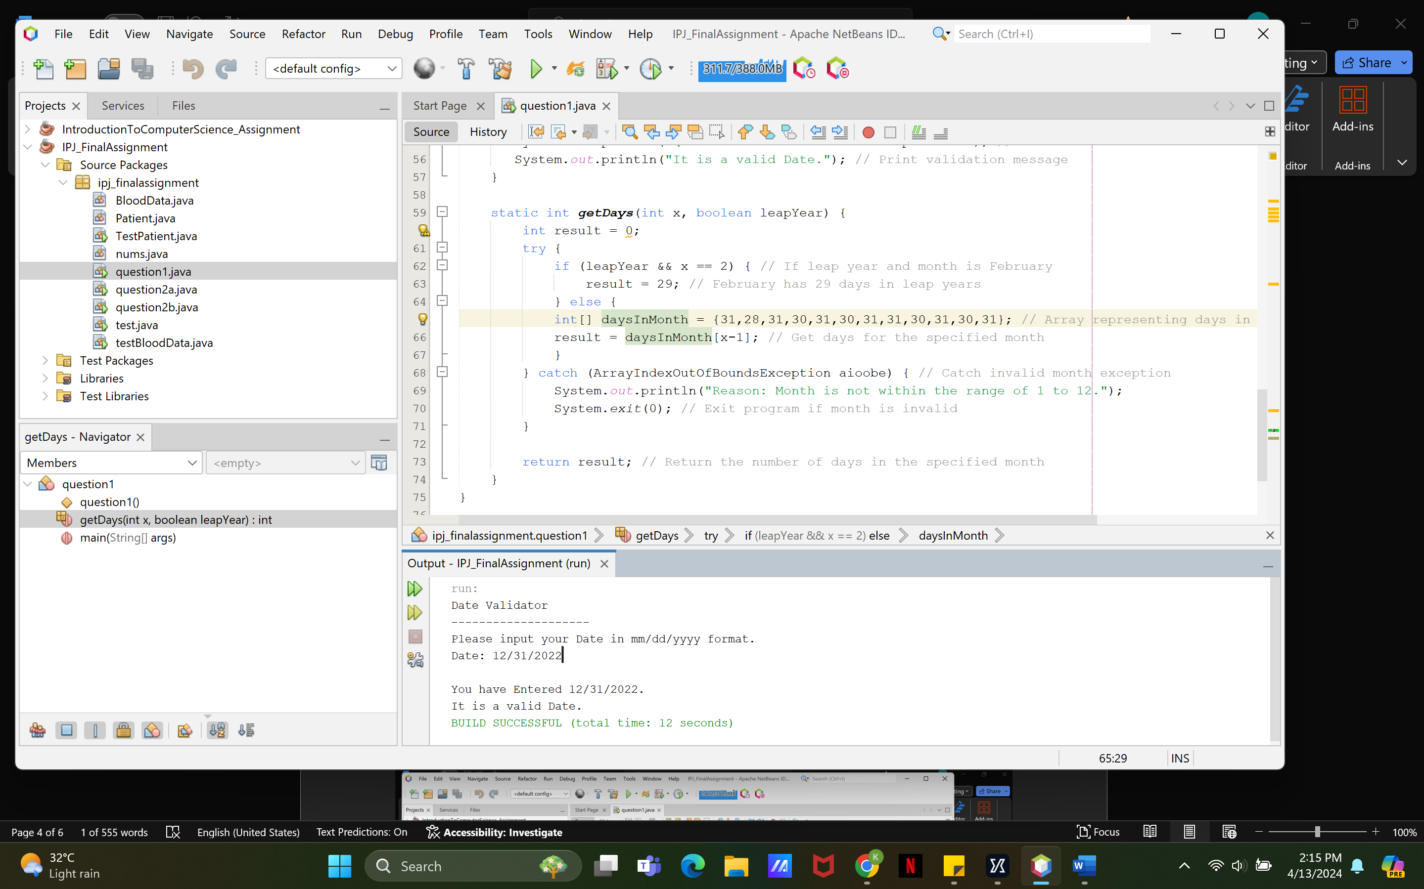

Test Case 3 (Error)

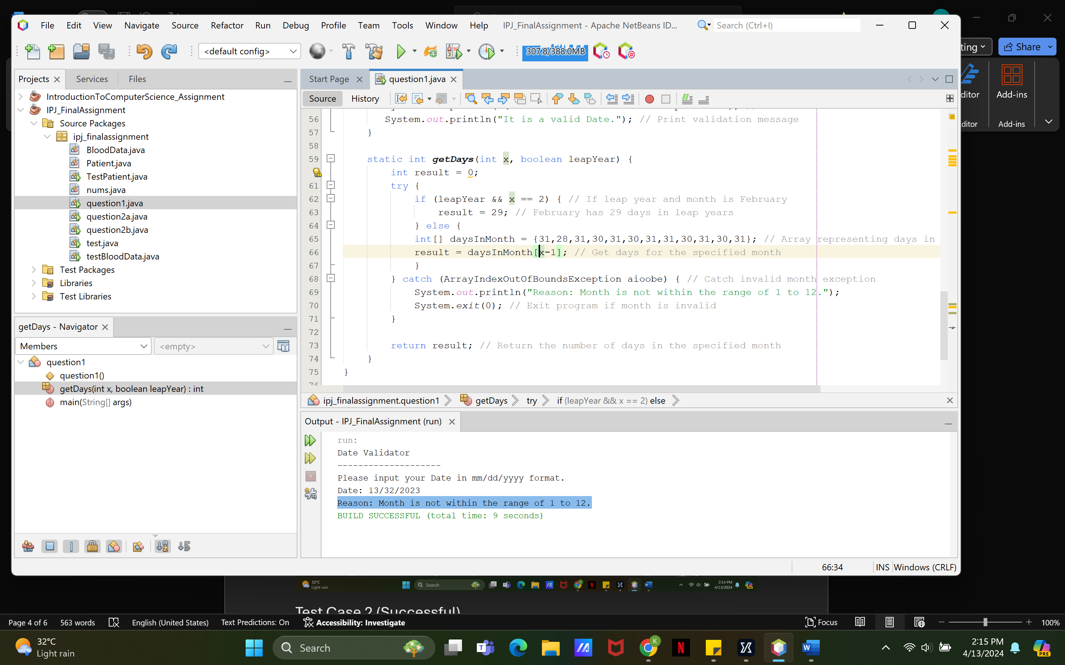

**Question 2a**

Code

package ipj_finalassignment;

import java.util.Scanner;

public class question2a {

public static void main(String[] args) {

Scanner sc = new Scanner(System.in);

String letterInput;

String result = "";

System.out.println("Telephone Number Converter");

System.out.println("--------------------");

System.out.println();

System.out.print("Please input the letters: ");

letterInput = sc.nextLine().toLowerCase().replaceAll(" ",""); // Take user input, convert to lowercase, and remove spaces

if (letterInput.length() > 7) { // Limit input to 7 characters

letterInput = letterInput.substring(0,7);

}

String regex = ".*[^a-zA-z].*"; // Regular expression to check for non-letter characters

if (letterInput.matches(regex)) { // Check if input contains non-letter characters

System.out.println("One of the character you entered is not a letter."); // Print error message

System.exit(0); // Exit program

}

System.out.println(letterInput); // Print the sanitized input

// Convert letters to numbers according to the telephone keypad

for (int i = 0; i < letterInput.length(); i++) {

char currentLetter = letterInput.charAt(i);

int currentNum = toDigit(currentLetter); // Convert current letter to corresponding number

result += currentNum; // Append the number to the result string

if (i == 2) { // Insert hyphen after the third digit

result += "-";

}

}

System.out.println(result); // Print the converted telephone number

}

// Method to convert a letter to its corresponding number on a telephone keypad

static int toDigit(char s) {

switch (s) {

case 'a','b','c':

return 2;

case 'd','e','f':

return 3;

case 'g','h','i':

return 4;

case 'j','k','l':

return 5;

case 'm','n','o':

return 6;

case 'p','q','r', 's':

return 7;

case 't','u','v':

return 8;

case 'w','x','y', 'z':

return 9;

default:

return 0; // Return 0 for non-letter characters

}

}

}

|  |  |  |  |
| --- | --- | --- | --- |
| Test Case | Input | Expected Output | Actual Output |
| 1 | "FLOWERS" | "356-9377" | "356-9377" |
| 2 | "GOTMILK" | "468-6455" | "468-6455" |
| 3 | "1234567" | "One of the characters you entered is not a letter." | "One of the characters you entered is not a letter." |

Test Case 1 (Successful)

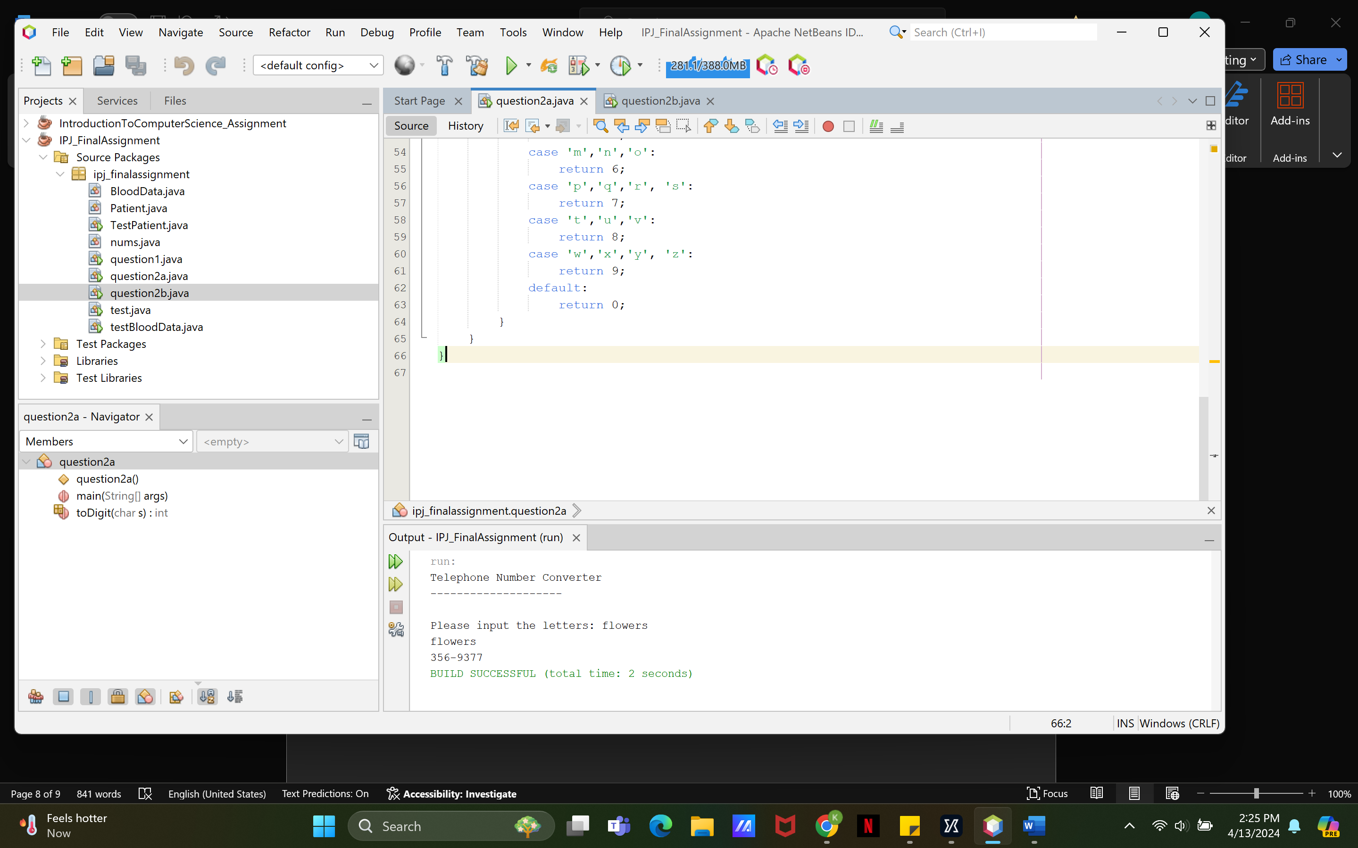

Test Case 2 (Successful)

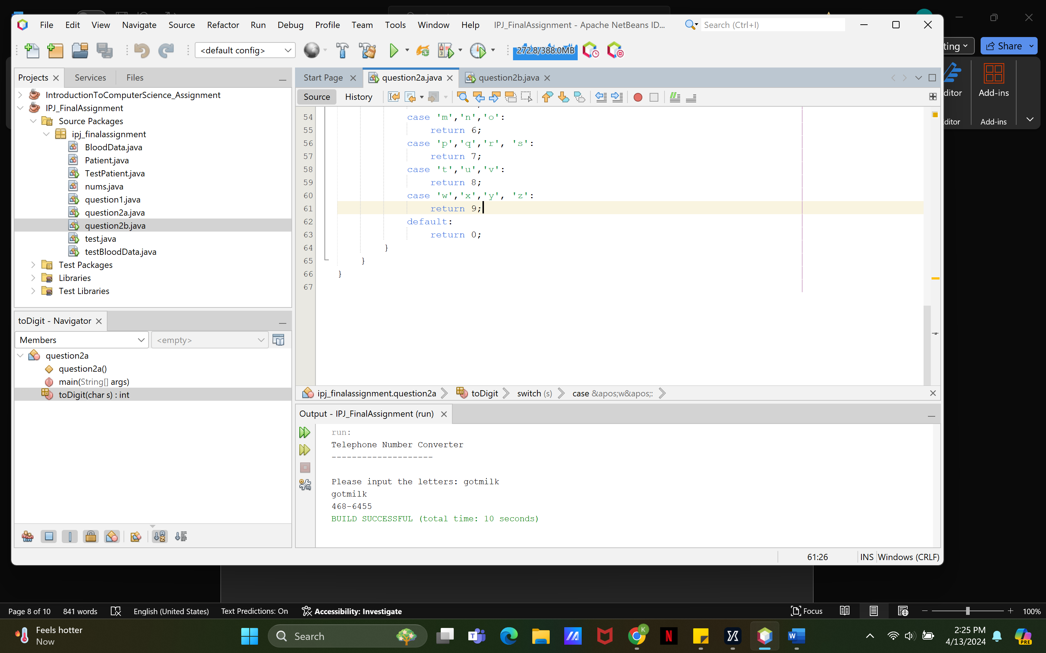

Test Case 3 (Error)

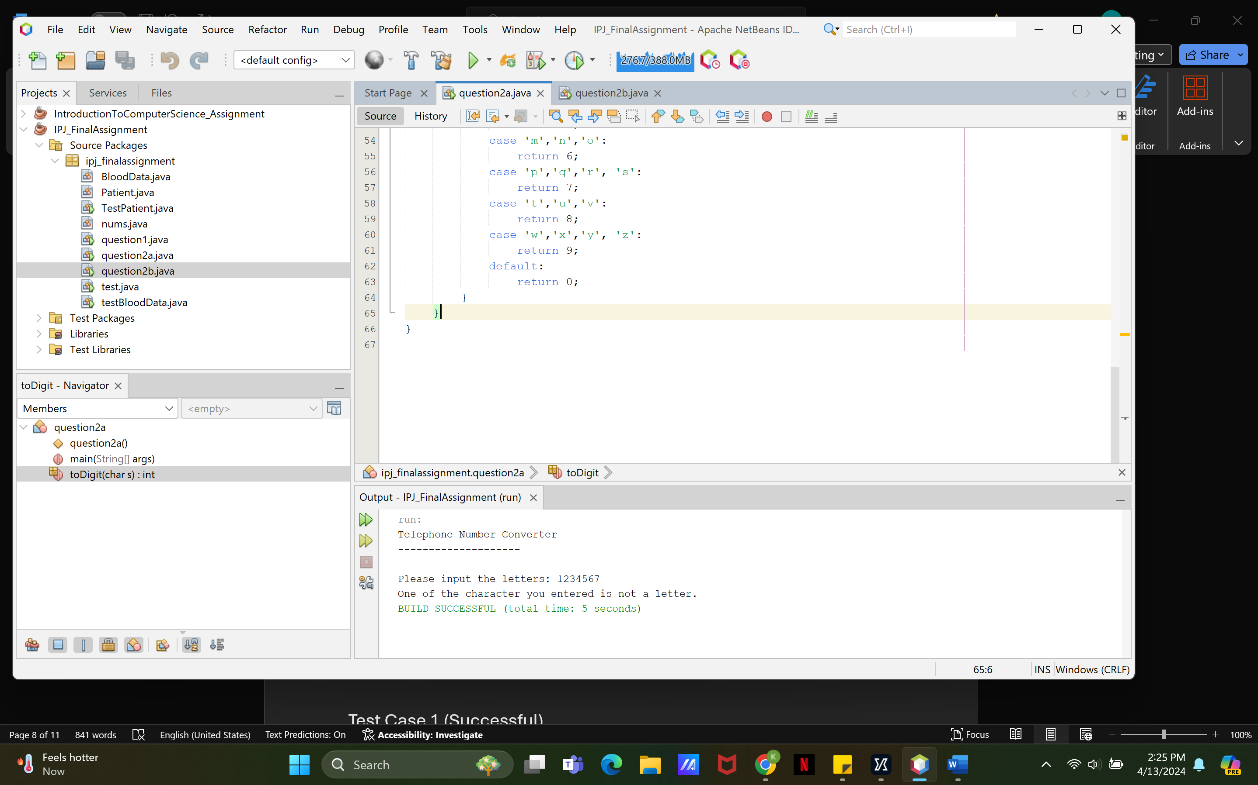

**Question 2b**

Code

|  |  |  |  |
| --- | --- | --- | --- |
| Test Case | Input | Expected Output | Actual Output |
| 1 | 2  "FLOWERS"  “GOTMILK" | The numbers you have entered are the following:  356-9377  468-6455 | The numbers you have entered are the following: 356-9377  468-6455 |
| 2 | 3  "HELLO"  "WORLD"  "OPEN" | "The numbers you have entered are the following:  435-56-36  967-53-895  673-6 | "The numbers you have entered are the following:  435-56-36  967-53-895  6736-24 |
| 3 | 2  1-800-123-4567  1234567 | "One of the characters you entered is not a letter." | "One of the characters you entered is not a letter." |

Test Case 1 (Successful)

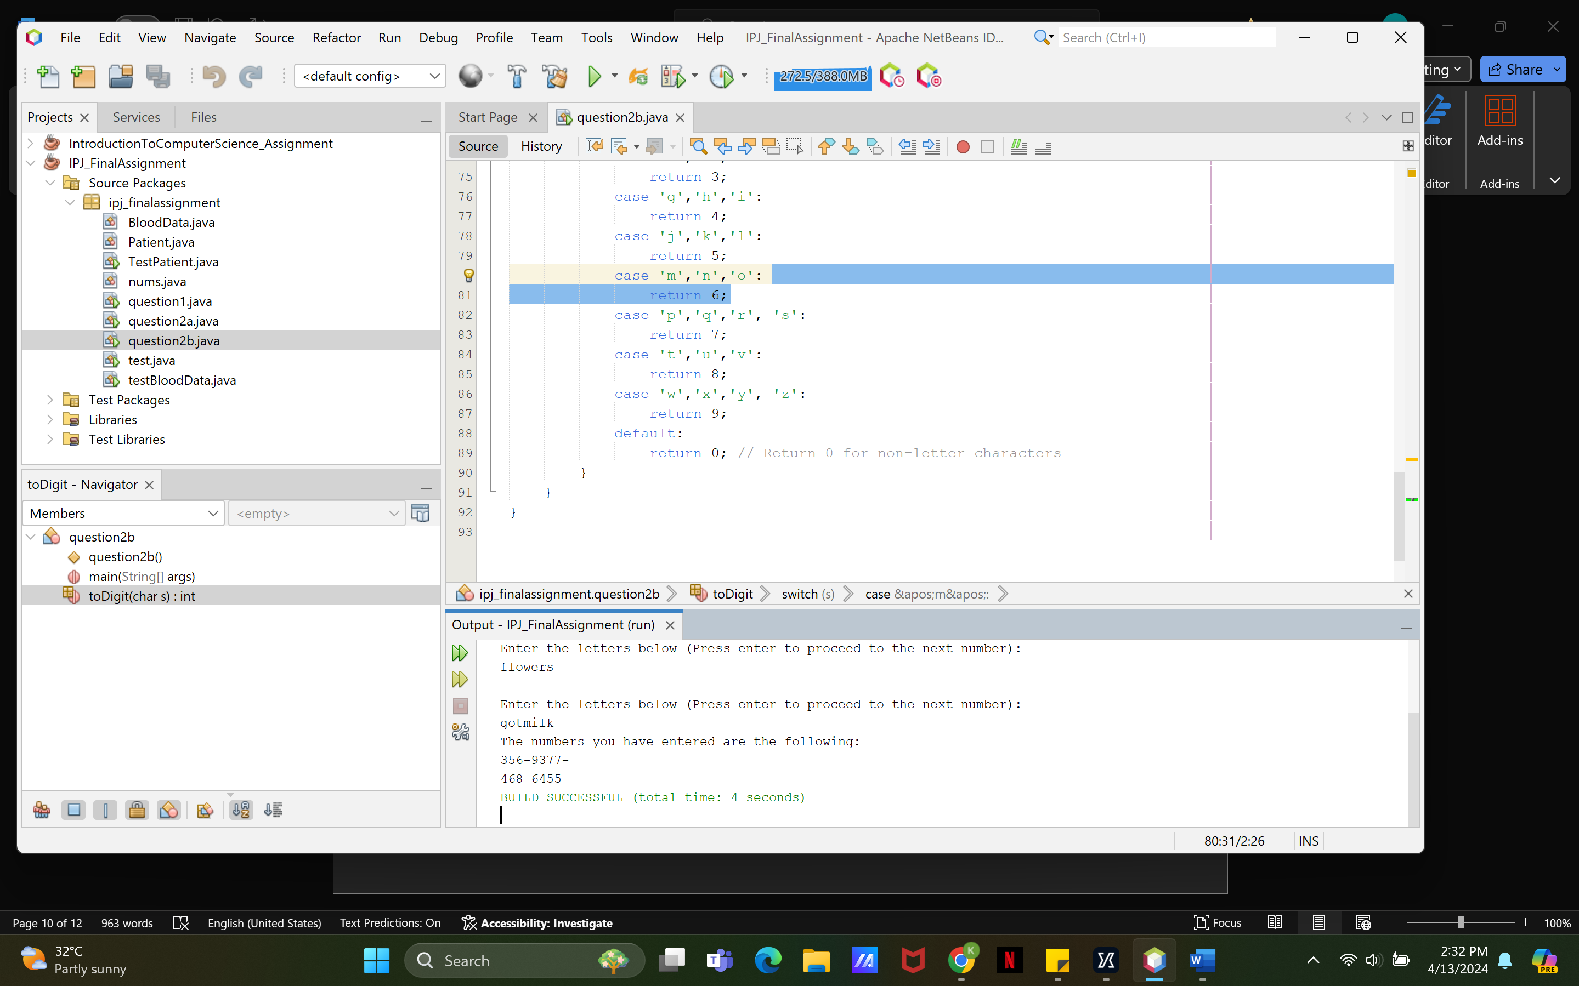

Test Case 2 (Successful)

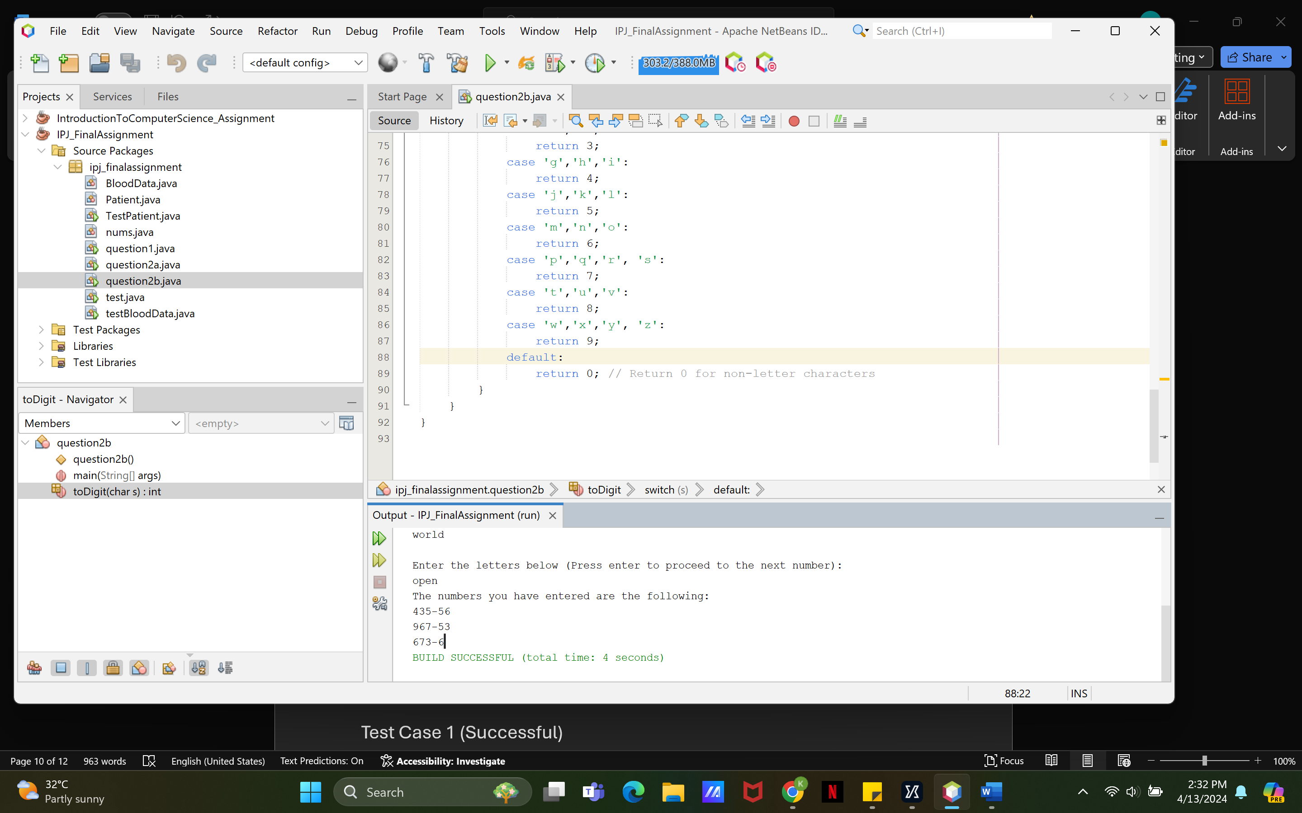

Test Case 3 (Error)

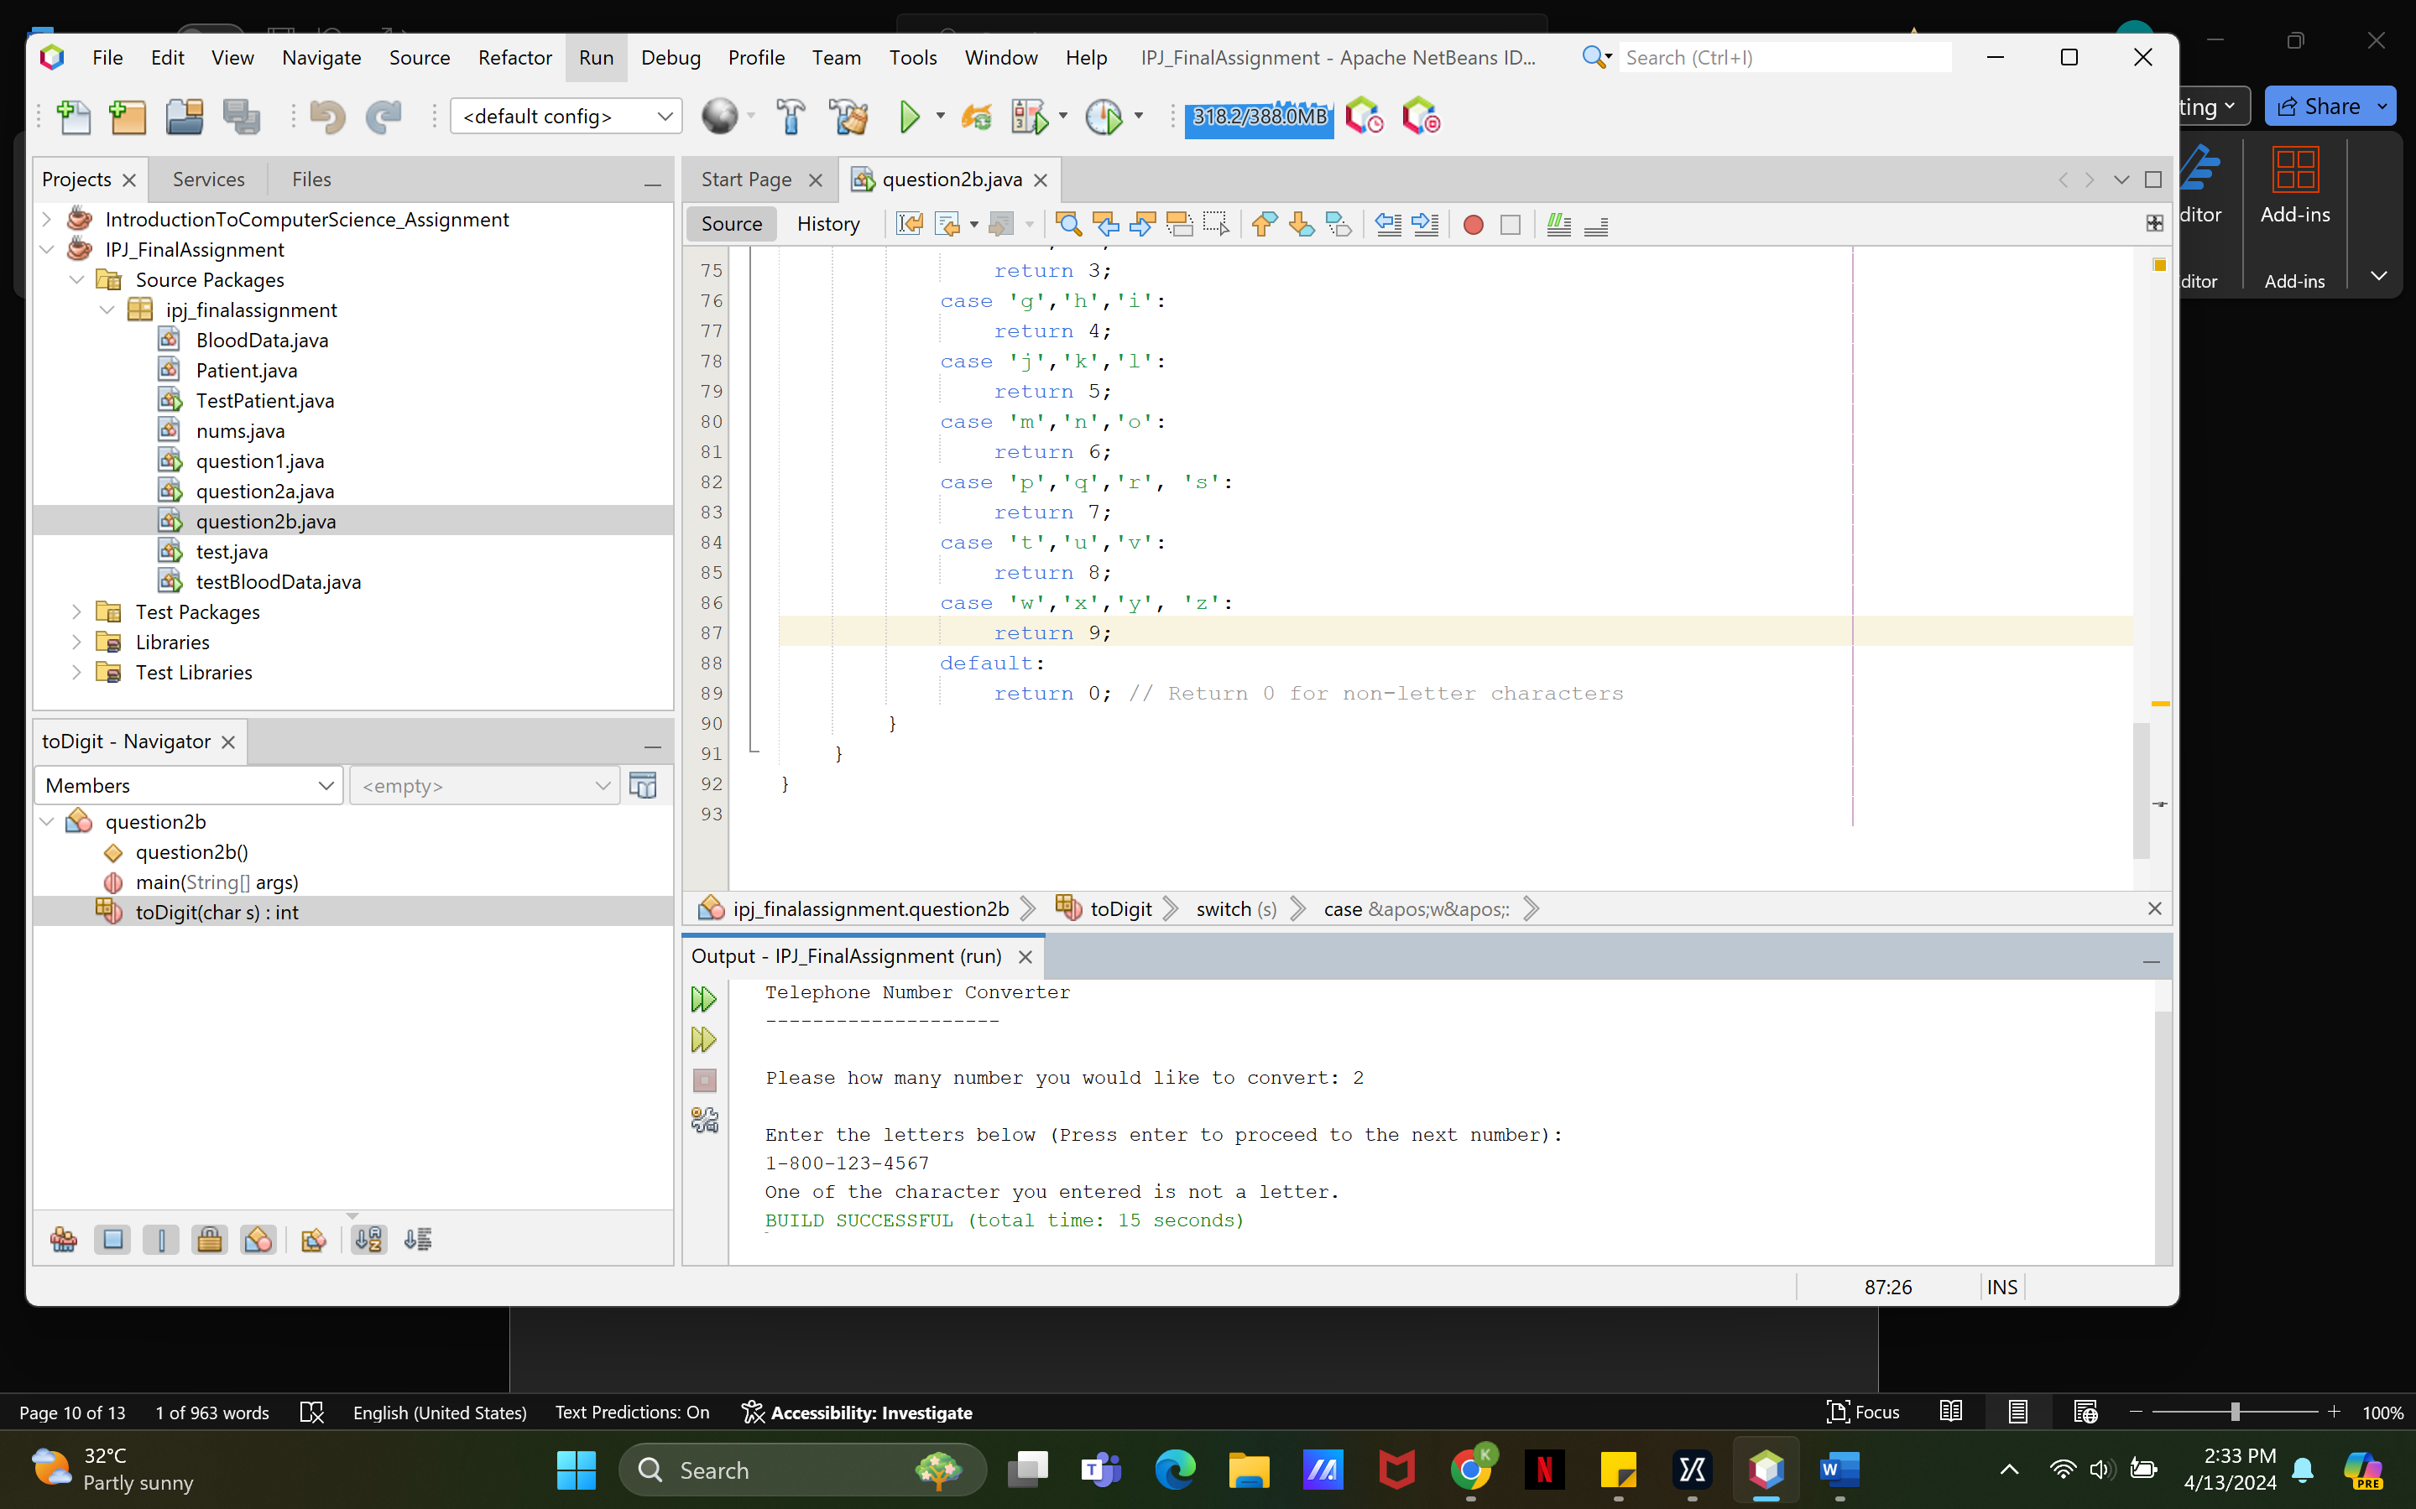

**Question 3a**

Code

package ipj_finalassignment;

public class Patient {

private int idNum;

private int age;

private BloodData bloodData;

// Default constructor for Patient class

public Patient() {

this.idNum = 0;

this.age = 0;

this.bloodData = new BloodData();

}

// Parameterized constructor for Patient class

public Patient(int id, int age) {

this.idNum = id;

this.age = age;

this.bloodData = new BloodData();

}

// Getter method for ID number

public int getIdNum() {

return idNum;

}

// Setter method for ID number

public void setIdNum(int x) {

this.idNum = x;

}

// Getter method for age

public int getAge() {

return age;

}

// Setter method for age

public void setAge(int x) {

this.age = x;

}

// Getter method for blood data

public BloodData getBloodData() {

return bloodData;

}

// Setter method for blood data

public void setBloodData(BloodData bloodData) {

this.bloodData = bloodData;

}

}

package ipj_finalassignment;

public class TestPatient {

public static void main(String[] args) {

// Create a new Patient object for Kevin without specifying ID and Age

Patient kevin = new Patient();

// Create a new Patient object for Euniese with specified ID and Age

Patient euniese = new Patient(3, 22);

// Get Kevin's blood data in a readable format

String kevinBloodData = kevin.getBloodData().getBloodType() + kevin.getBloodData().getRhFactor();

// Get Euniese's blood data in a readable format

String eunieseBloodData = euniese.getBloodData().getBloodType() + euniese.getBloodData().getRhFactor();

// Display Kevin's information

System.out.println("Kevin's ID Number is " + kevin.getIdNum());

System.out.println("Kevin's Age is " + kevin.getAge());

System.out.println("Kevin's Blood Data is " + kevinBloodData);

System.out.println();

// Display Euniese's information

System.out.println("Euniese's ID Number is " + euniese.getIdNum());

System.out.println("Euniese's Age is " + euniese.getAge());

System.out.println("Euniese's Blood Data is " + eunieseBloodData );

System.out.println();

// Update Kevin's information

kevin.setAge(24);

kevin.setIdNum(2);

BloodData kevinNewBloodData = new BloodData("A", '+');

kevin.setBloodData(kevinNewBloodData);

kevinBloodData = kevin.getBloodData().getBloodType() + kevin.getBloodData().getRhFactor();

// Display Kevin's updated information

System.out.println("Kevin's New ID Number is " + kevin.getIdNum());

System.out.println("Kevin's New Age is " + kevin.getAge());

System.out.println("Kevin's New Blood Data is " + kevinBloodData);

}

}

|  |  |  |  |
| --- | --- | --- | --- |
| Test Case | Input/Action | Expected Output | Actual Output |
| 1 | No input | Kevin's Blood Type is O  Kevin's RH Factor is + | Kevin's Blood Type is O  Kevin's RH Factor is + |
| 2 | "A", '-' | Euniese's Blood Type is A  Euniese's RH Factor is - | Euniese's Blood Type is A  Euniese's RH Factor is - |
| 3 | kevin.setBloodType(null) | BloodType: null, RhFactor: + | BloodType: null, RhFactor: + |

Test Case 1 (Successful)

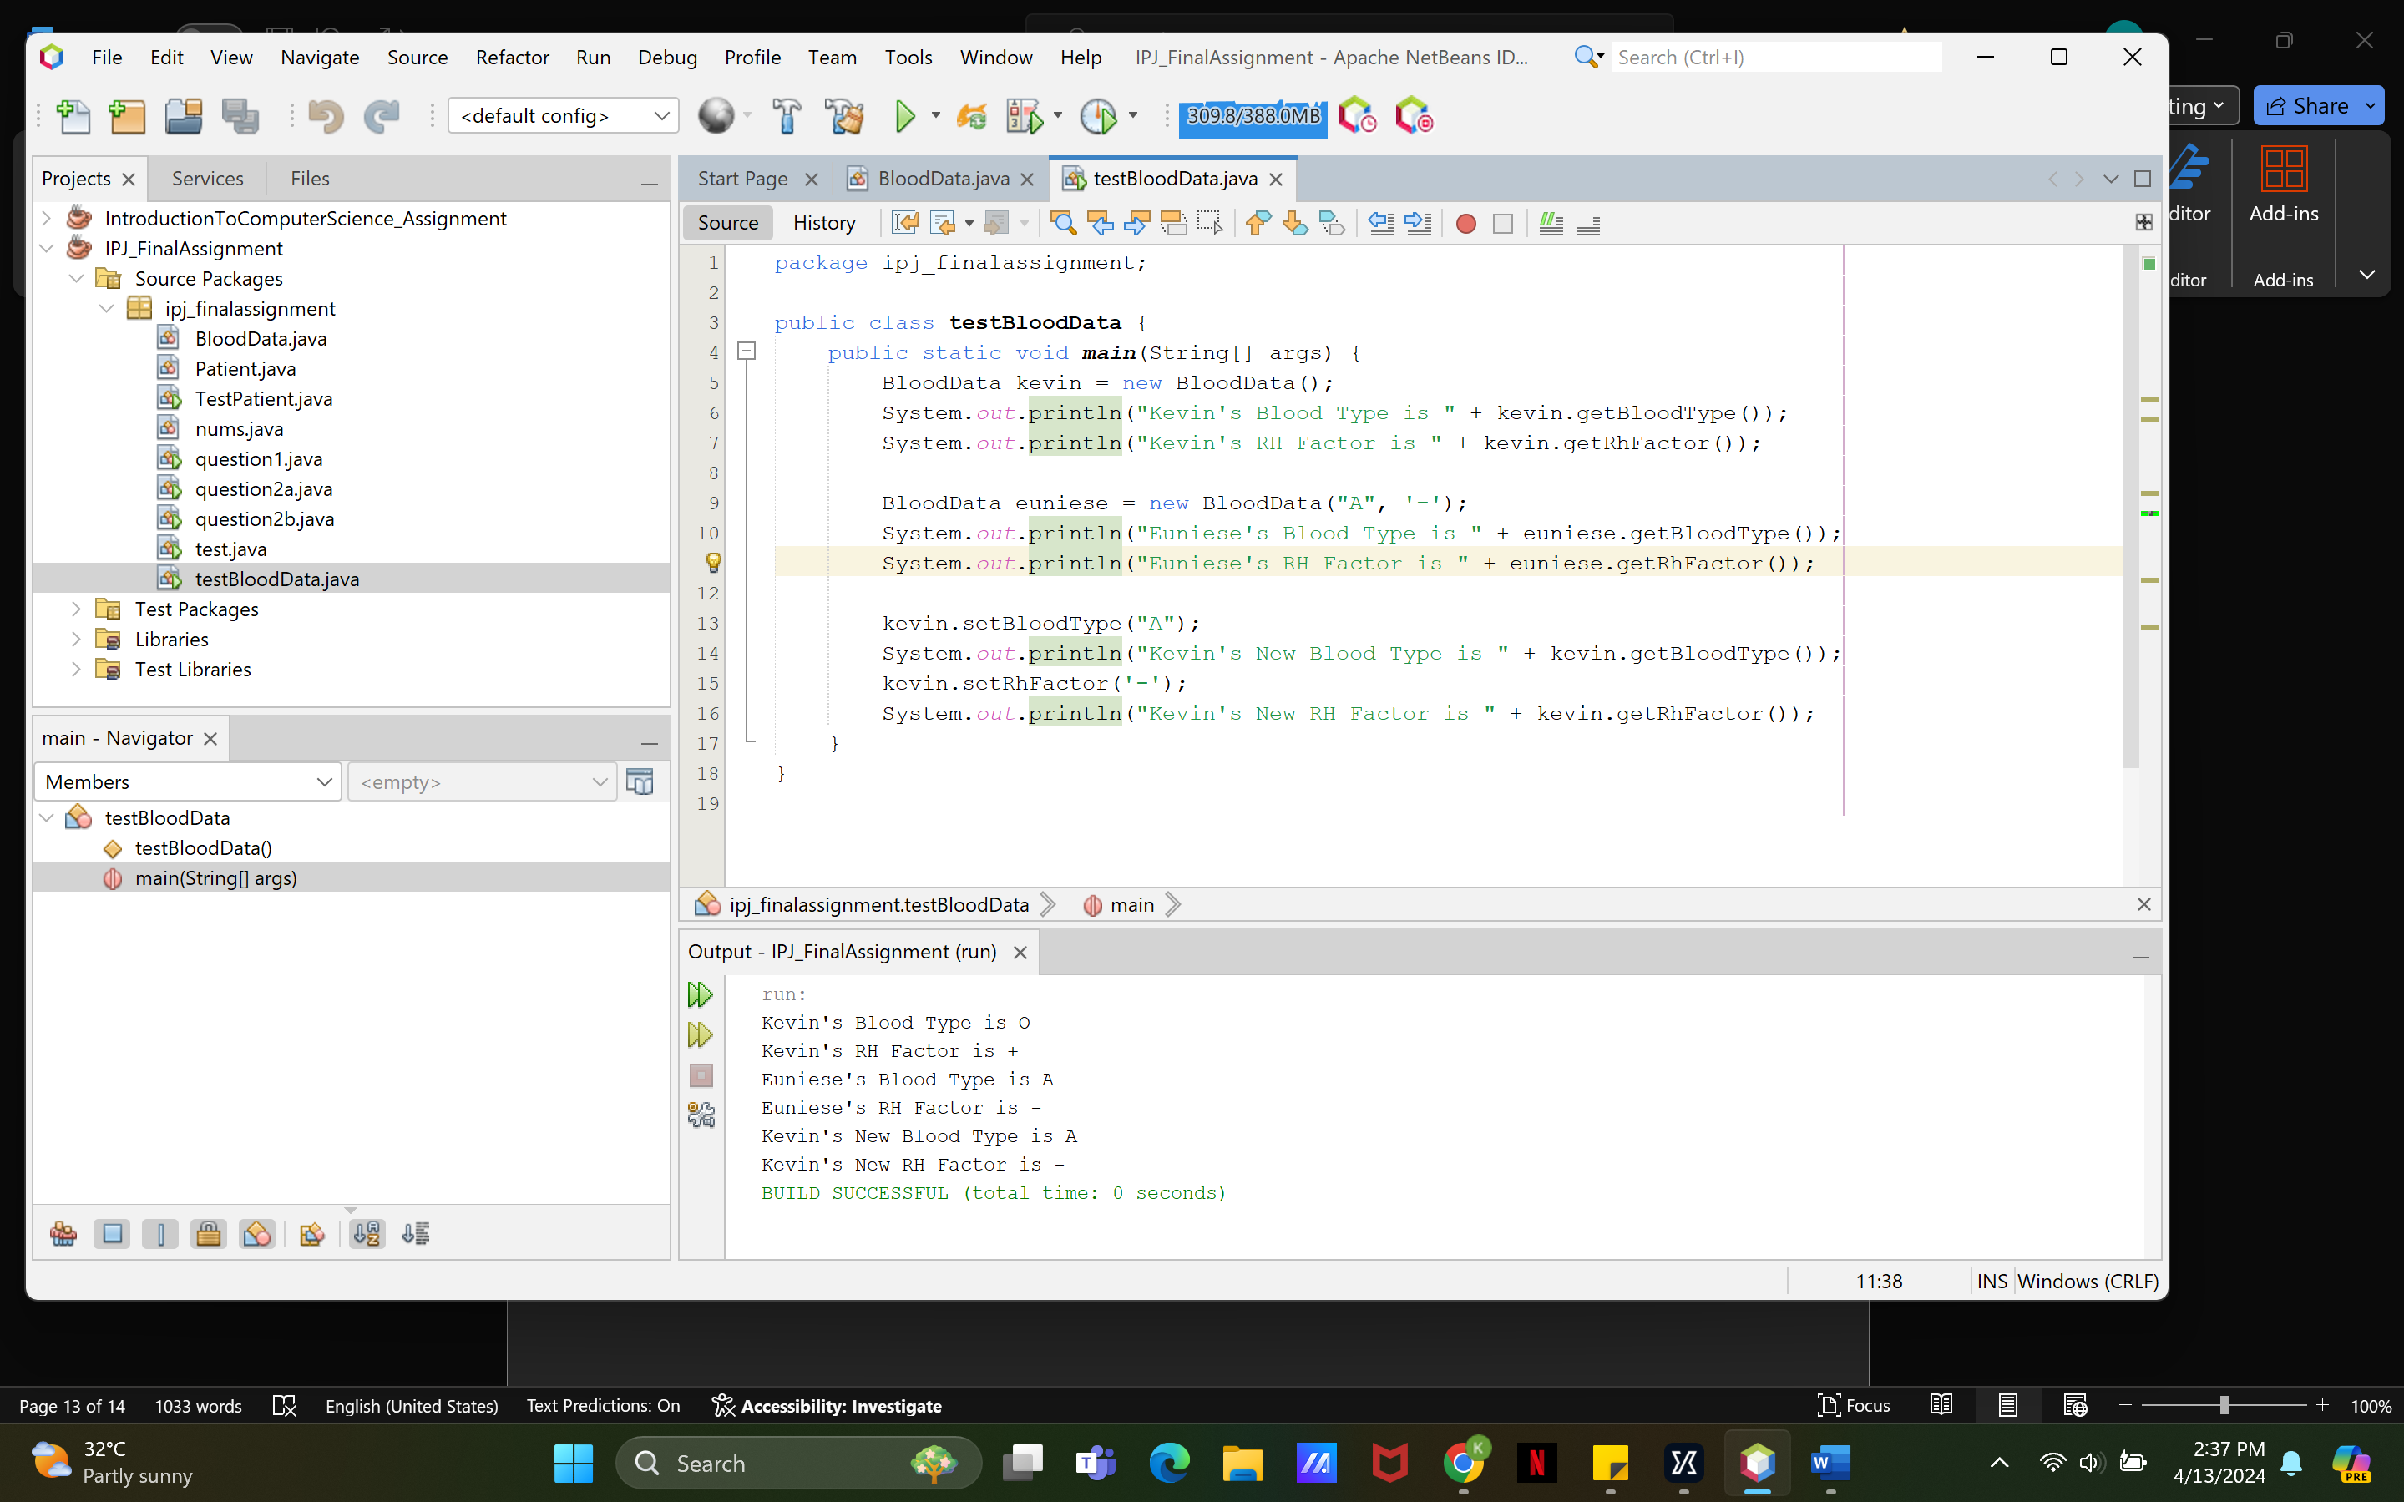

Test Case 2 (Successful)



Test Case 3 (Error)

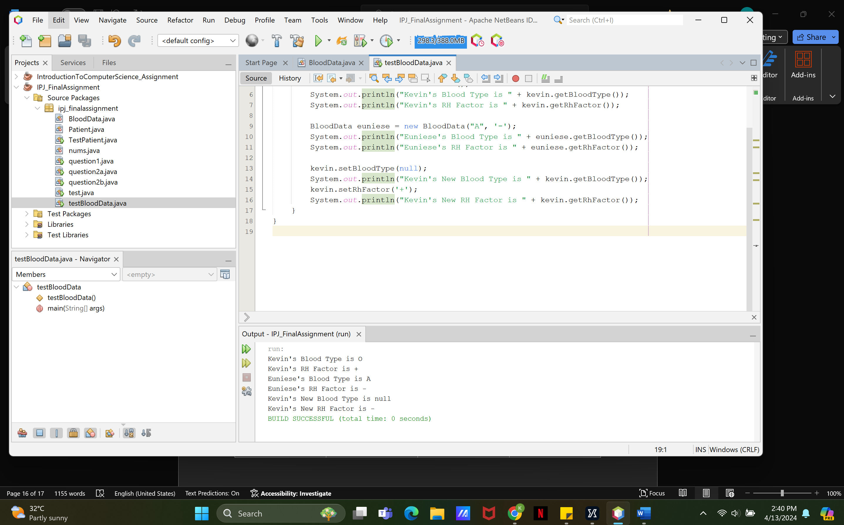

**Question 3b**

Code

package ipj_finalassignment;

public class Patient {

private int idNum;

private int age;

private BloodData bloodData;

public Patient() {

this.idNum = 0;

this.age = 0;

this.bloodData = new BloodData();

}

public Patient(int id, int age) {

this.idNum = id;

this.age = age;

this.bloodData = new BloodData();

}

public int getIdNum() {

return idNum;

}

public void setIdNum(int x) {

this.idNum = x;

}

public int getAge() {

return age;

}

public void setAge(int x) {

this.age = x;

}

public BloodData getBloodData() {

return bloodData;

}

public void setBloodData(BloodData bloodData) {

this.bloodData = bloodData;

}

}

package ipj_finalassignment;

public class TestPatient {

public static void main(String[] args) {

Patient kevin = new Patient();

Patient euniese = new Patient(3, 22);

String kevinBloodData = kevin.getBloodData().getBloodType() + kevin.getBloodData().getRhFactor();

String eunieseBloodData = euniese.getBloodData().getBloodType() + euniese.getBloodData().getRhFactor();

System.out.println("Kevin's ID Number is " + kevin.getIdNum());

System.out.println("Kevin's Age is " + kevin.getAge());

System.out.println("Kevin's Blood Data is " + kevinBloodData);

System.out.println();

System.out.println("Euniese's ID Number is " + euniese.getIdNum());

System.out.println("Euniese's Age is " + euniese.getAge());

System.out.println("Euniese's Blood Data is " + eunieseBloodData );

System.out.println();

kevin.setAge(24);

kevin.setIdNum(2);

BloodData kevinNewBloodData = new BloodData("A", '+');

kevin.setBloodData(kevinNewBloodData);

kevinBloodData = kevin.getBloodData().getBloodType() + kevin.getBloodData().getRhFactor();

System.out.println("Kevin's New ID Number is " + kevin.getIdNum());

System.out.println("Kevin's New Age is " + kevin.getAge());

System.out.println("Kevin's New Blood Data is " + kevinBloodData);

}

}

|  |  |  |  |
| --- | --- | --- | --- |
| Test Case | Input/Action | Expected Output | Actual Output |
| 1 | No input | Kevin's ID Number is 0  Kevin's Age is 0  Kevin's Blood Data is O+ | Kevin's ID Number is 0  Kevin's Age is 0  Kevin's Blood Data is O+ |
| 2 | ID: 3, Age: 22 | Euniese's ID Number is 3  Euniese's Age is 22  Euniese's Blood Data is O+ | Euniese's ID Number is 3  Euniese's Age is 22  Euniese's Blood Data is O+ |
| 3 | kevin.setAge(24)  kevin.setIdNum(2)  kevin.setBloodData(new BloodData("A", '+')) | Kevin's New ID Number is 2  Kevin's New Age is 24  Kevin's New Blood Data is A+ | Kevin's New ID Number is 2  Kevin's New Age is 24  Kevin's New Blood Data is A+ |

Test Case 1 (Successful)

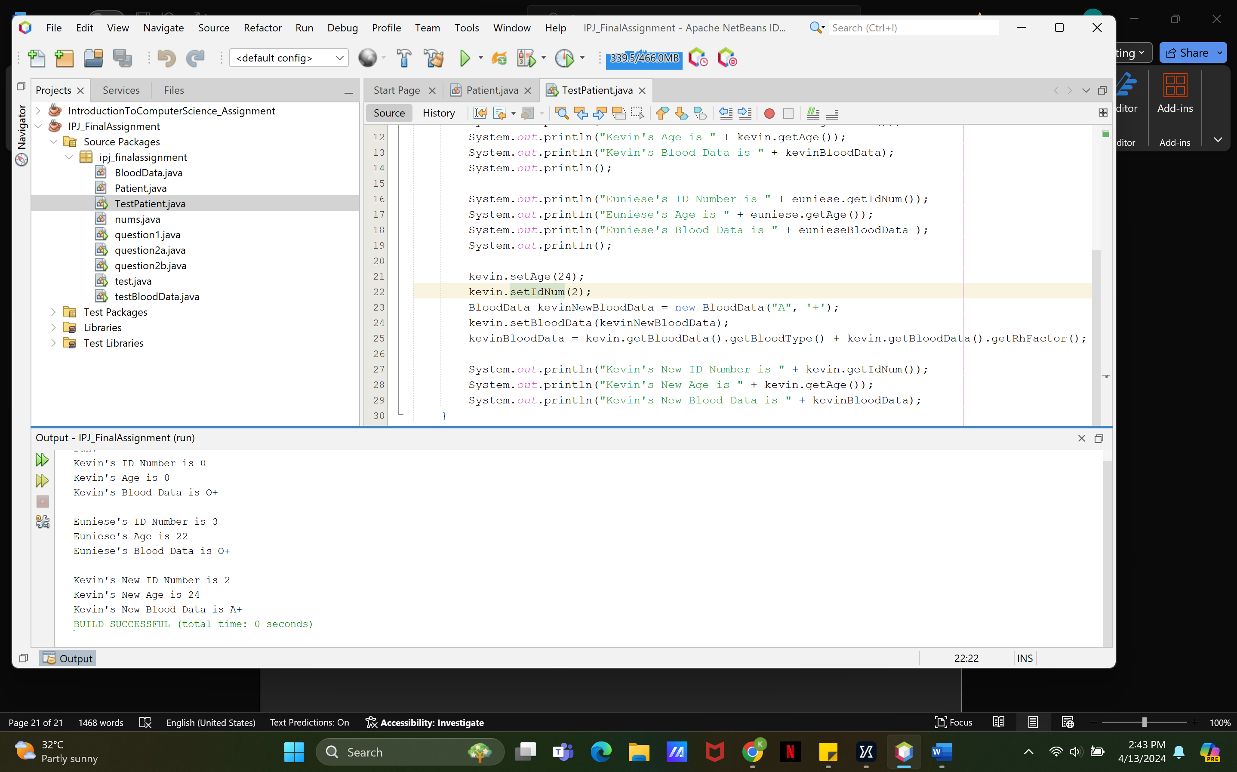

Test Case 2 (Successful)



Test Case 3 (Error)

